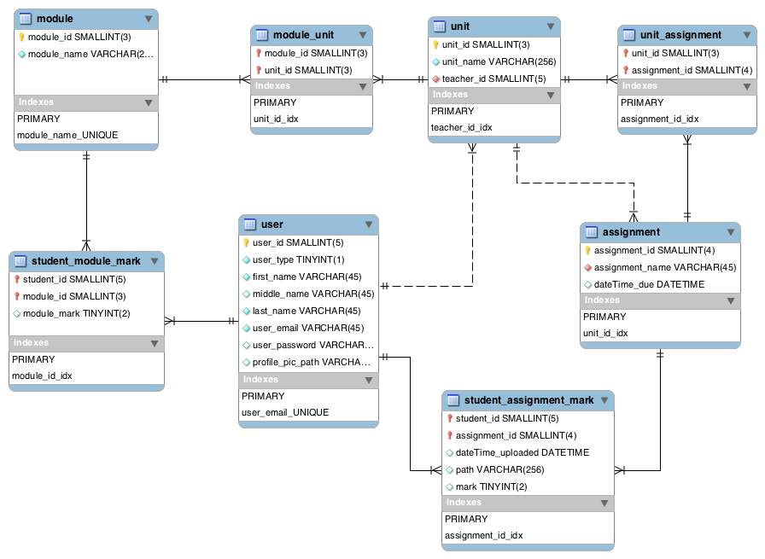

|  |  |  |  |  |  |  |  |
| --- | --- | --- | --- | --- | --- | --- | --- |
| **USER** | | | | | | | |
| user_id | user_type | first_name | middle_name | last_name | user_email | user_password | profile_pic_path |
| 00001 | 0 | Juan | Carlos | Munoz | juancmcalle@gmail.com | NULL | NULL |
| 00002 | 1 | Itai | NULL | Bercovier | i.bercovier@sae.edu | NULL | NULL |
| 00003 | 1 | Subrata | NULL | Chakraborty | s.chakraborty@sae.edu | NULL | NULL |
| 00004 | 2 | Rose | NULL | Cavendish | r.cavendish@sae.edu | NULL | NULL |
| 00005 | 0 | Vladimir | NULL | Shylock | v.shylock@sae.edu | NULL | NULL |
| 00006 | 1 | John | NULL | Kennedy | johnskennedy@gmail.com | NULL | NULL |
| 00007 | 1 | Pete | NULL | Croaker | p.croaker@sae.edu | NULL | NULL |
| 00008 | 0 | Umar | NULL | Shahid | u.shahid@sae.edu | NULL | NULL |

|  |  |
| --- | --- |
| **UNIT_ASSIGNMENT** | |
| unit_id | assignment_id |
| 001 | 0001 |
| 001 | 0002 |
| 002 | 0003 |
| 002 | 0004 |
| 003 | 0005 |
| 004 | 0006 |
| 005 | 0007 |
| 005 | 0008 |
| 006 | 0009 |
| 006 | 0010 |
| 006 | 0011 |
| ALSO FOREIGN | |

|  |  |  |
| --- | --- | --- |
| **UNIT** | | |
| unit_id | unit_name | teacher_id |
| 001 | HTML/CSS | 00002 |
| 002 | Intro to Javascript | 00007 |
| 003 | Principles of Design | 00002 |
| 004 | Human Computer Interaction | 00002 |
| 005 | PHP/MySQL | 00003 |
| 006 | Intro to Flash | 00006 |

|  |  |
| --- | --- |
| **MODULE** | |
| module_id | module_name |
| 401 | Introduction to Scripting, Programming, Interface Design and Communication |
| 402 | Key Technologies for Interaction |

|  |  |  |
| --- | --- | --- |
| **ASSIGNMENT** | | |
| assignment_id | assignment_name | dateTime_due |
| 0001 | Website Proposal | NULL |
| 0002 | Website Project | NULL |
| 0003 | Form Validation | NULL |
| 0004 | Image Gallery | NULL |
| 0005 | Principles of Design Project | NULL |
| 0006 | Usability Report | NULL |
| 0007 | Dynamic Website Proposal | NULL |
| 0008 | Dynamic Website Project | NULL |
| 0009 | Animated Logo | NULL |
| 0010 | Interactive Banner | NULL |
| 0011 | Flash Website | NULL |

|  |  |  |
| --- | --- | --- |
| **MODULE_MARK** | | |
| student_id | module_id | module_mark |
| 00001 | 402 | NULL |
| 00005 | 402 | NULL |
| 00008 | 402 | NULL |
| ALSO FOREIGN | |

|  |  |  |  |  |
| --- | --- | --- | --- | --- |
| **STUDENT_ASSIGNMENT_MARK** | | | | |
| student_id | assignment_id | time_uploaded | path | mark |
| 00001 | 0006 | NULL | NULL | NULL |
| 00001 | 0007 | NULL | NULL | NULL |
| 00001 | 0008 | NULL | NULL | NULL |
| 00001 | 0009 | NULL | NULL | NULL |
| 00001 | 0010 | NULL | NULL | NULL |
| 00001 | 0011 | NULL | NULL | NULL |
| 00005 | 0006 | NULL | NULL | NULL |
| 00005 | 0007 | NULL | NULL | NULL |
| 00005 | 0008 | NULL | NULL | NULL |
| 00005 | 0009 | NULL | NULL | NULL |
| 00005 | 0010 | NULL | NULL | NULL |
| 00005 | 0011 | NULL | NULL | NULL |
| 00008 | 0006 | NULL | NULL | NULL |
| 00008 | 0007 | NULL | NULL | NULL |
| 00008 | 0008 | NULL | NULL | NULL |
| 00008 | 0009 | NULL | NULL | NULL |
| 00008 | 0010 | NULL | NULL | NULL |
| 00008 | 0011 | NULL | NULL | NULL |
| ALSO FOREIGN | |

|  |  |
| --- | --- |
| **MODULE_UNIT** | |
| module_id | unit_id |
| 401 | 001 |
| 401 | 002 |
| 401 | 003 |
| 402 | 004 |
| 402 | 005 |
| 402 | 006 |
| ALSO FOREIGN | |

­­­

Foreign Key

Primary Key